|  |
| --- |
| **TIC TAC TOE**  **21CSS101J – PROGRAMMING FOR PROBLEM SOLVING**  **Mini Project Report**  *Submitted by*  **Parvathy V Nair [Reg. No : RA2211003010295]**  **B.Tech. CSE - Core**  **Anyesha Biswas [Reg. No : RA2211003010298]**  **B.Tech. CSE - Core**  **SRMIST-01.jpg**  **SCHOOL OF COMPUTING**  **COLLEGE OF ENGINEERING AND TECHNOLOGY**  **SRM INSTITUTE OF SCIENCE AND TECHNOLOGY**  **(Under Section 3 of UGC Act, 1956)**  S.R.M. NAGAR, KATTANKULATHUR – 603 203  KANCHEEPURAM DISTRICT  **December 2022** |

**TABLE OF CONTENTS**

|  |  |  |
| --- | --- | --- |
| **Chapter No.** | **Title** | **Page No.** |
| 1. | Problem Statement | 3 |
| 2. | Methodology / Procedure | 4 |
| 3. | Coding (C or Python) | 5 |
| 4. | Results | 8 |
| 5. | Conclusion | 9 |

**PROBLEM STATEMENT**:

**Program a two-person game of tic-tac-toe played on a three-by-three board. each person has a marker, one has 'X' and other 'O'. Players alternate their turns to place the marker on the board. The first player to get three in a row either diagonally, horizontally, or vertically, wins the games. In the event all squares are taken on the board without a winner then it is a tie. Player one should be assigned an ‘O’ as their marker, player two should be assigned the ‘X’. After the game has been completed, the program should congratulate the winner by name.PROCEDURE / METHODOLOGY**:

**1. Create a board using a 2-dimensional array and initialize each element as empty.**

**2. You can represent empty using any symbol you like. Here, we are going to use a hyphen. '-'.**

**3. Write a function to check whether the board is filled or not.**

**4. Iterate over the board and return false if the board contains an empty sign or else return true.**

**5. Write a function to check whether a player has won or not.**

**6. We have to check all the possibilities that we discussed in the previous section.**

**7. Check for all the rows, columns, and two diagonals.**

**8. Write a function to show the board as we will show the board multiple times to the users while they are playing.**

**9. Write a function to start the game.**

**10. Select the first turn of the player randomly.**

**11. Write an infinite loop that breaks when the game is over (either win or draw).**

**12. Show the board to the user to select the spot for the next move.**

**13. Ask the user to enter the row and column number.**

**14. Update the spot with the respective player sign.**

**15. Check whether the current player won the game or not.**

**16. If the current player won the game, then print a winning message and break the infinite loop.**

**17. Next, check whether the board is filled or not.**

**If the board is filled, then print the draw message and break the infinite loop.**

**18. Finally, show the user the final view of the board.**

**CODING (PYTHON):**

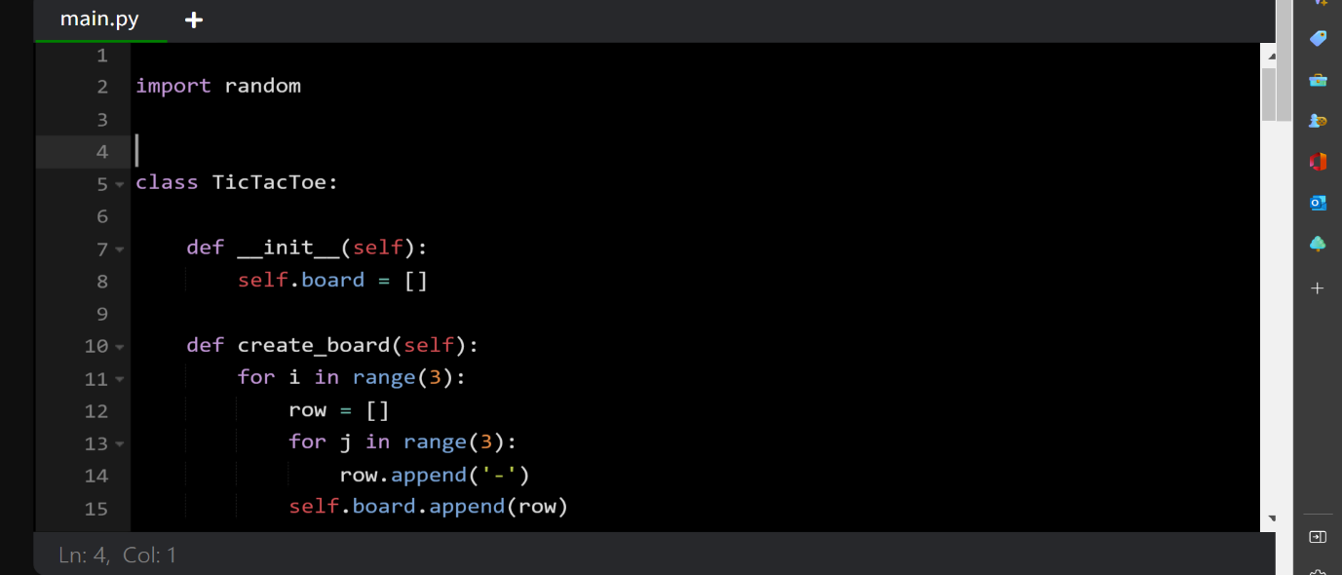

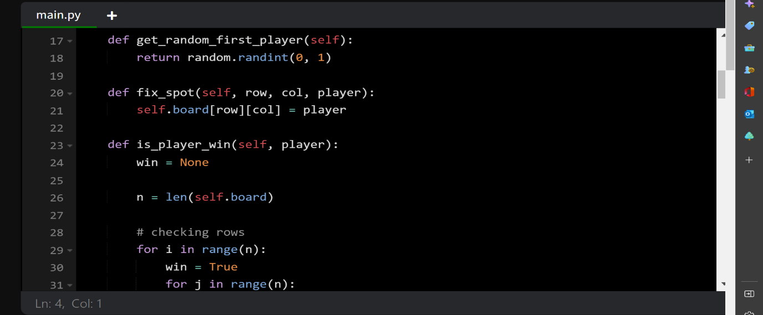

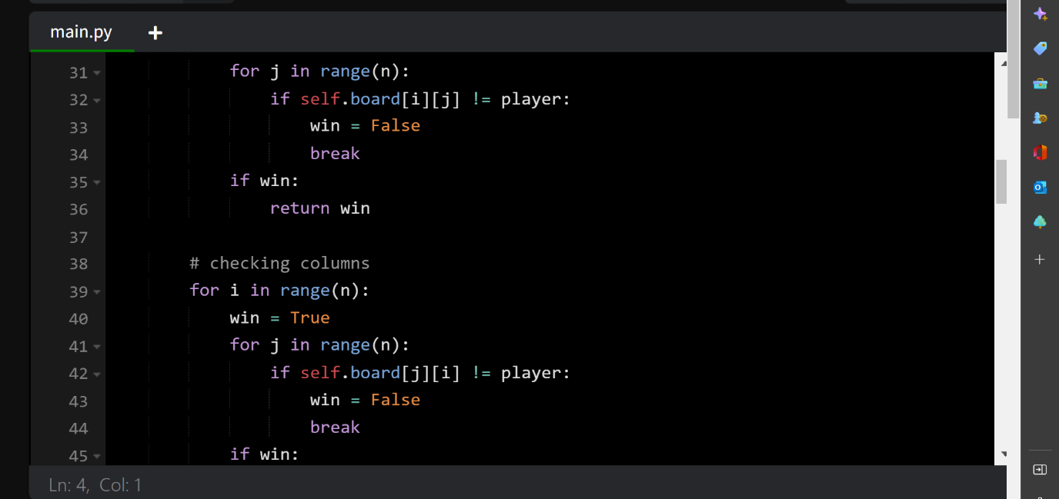

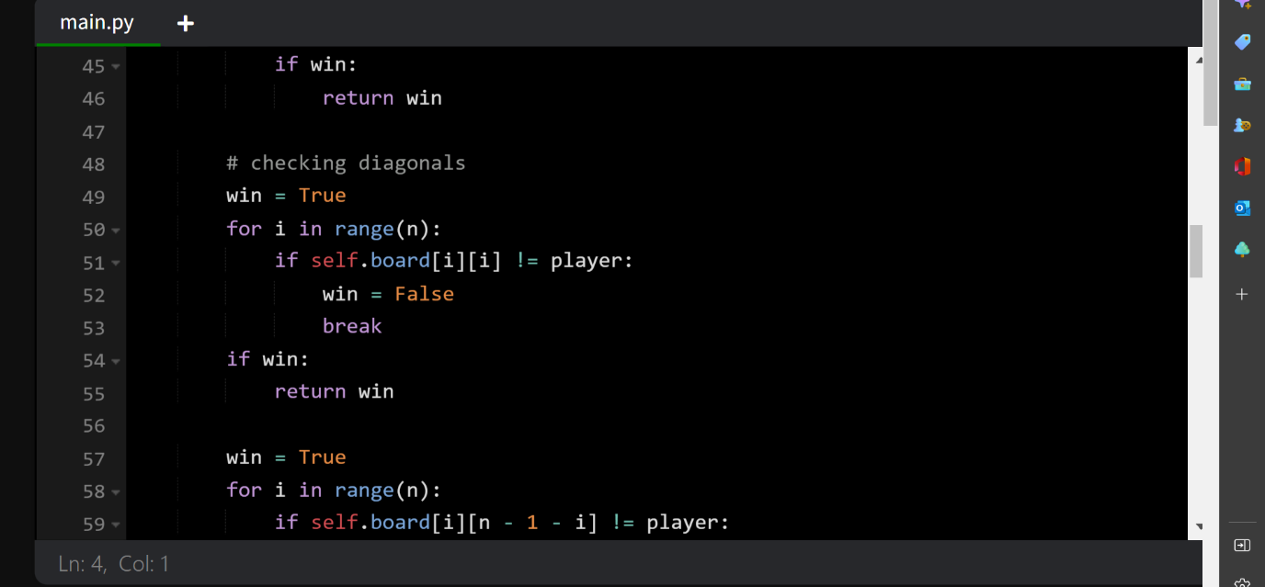

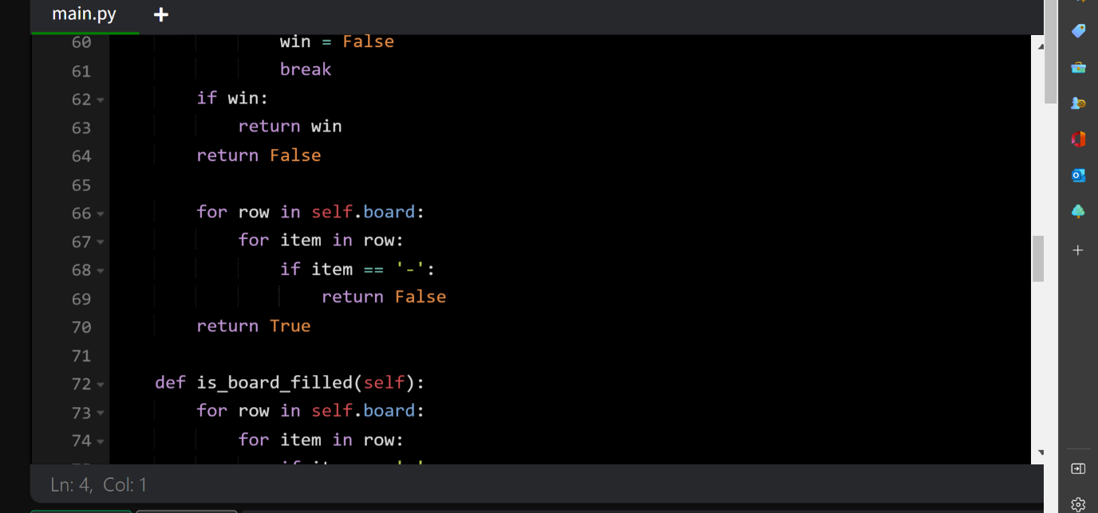

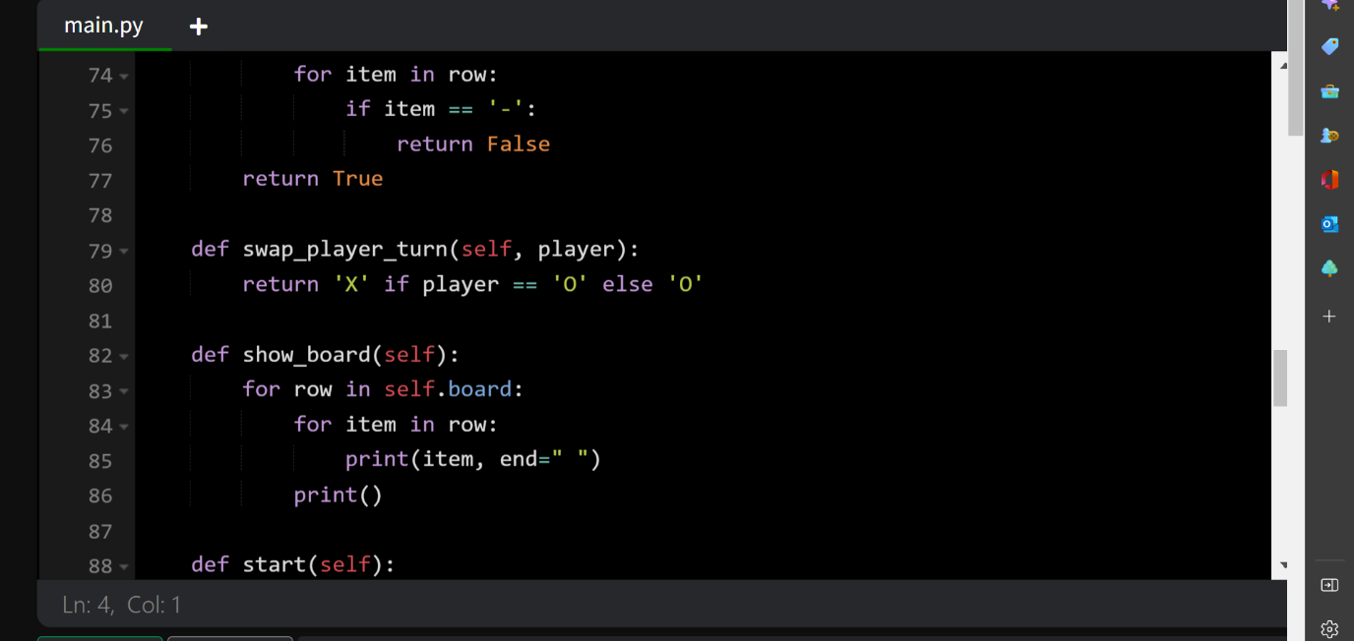

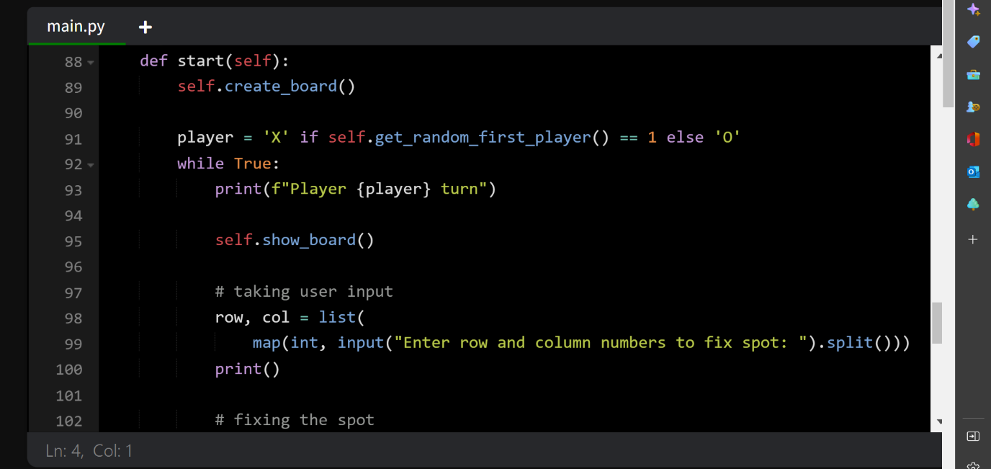

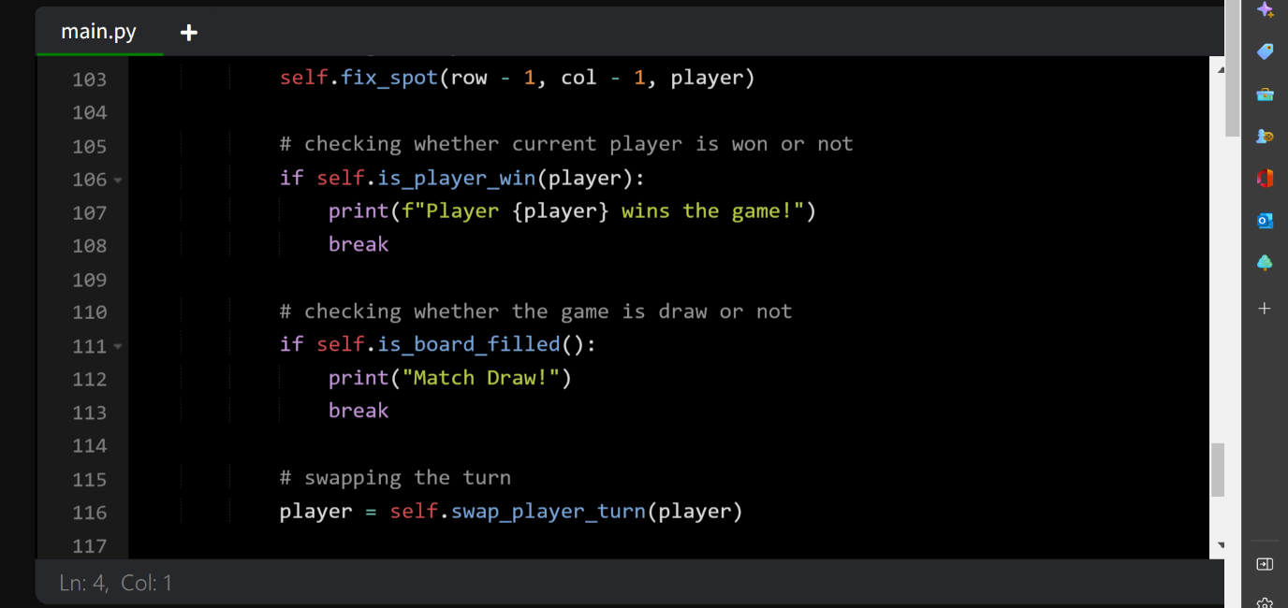

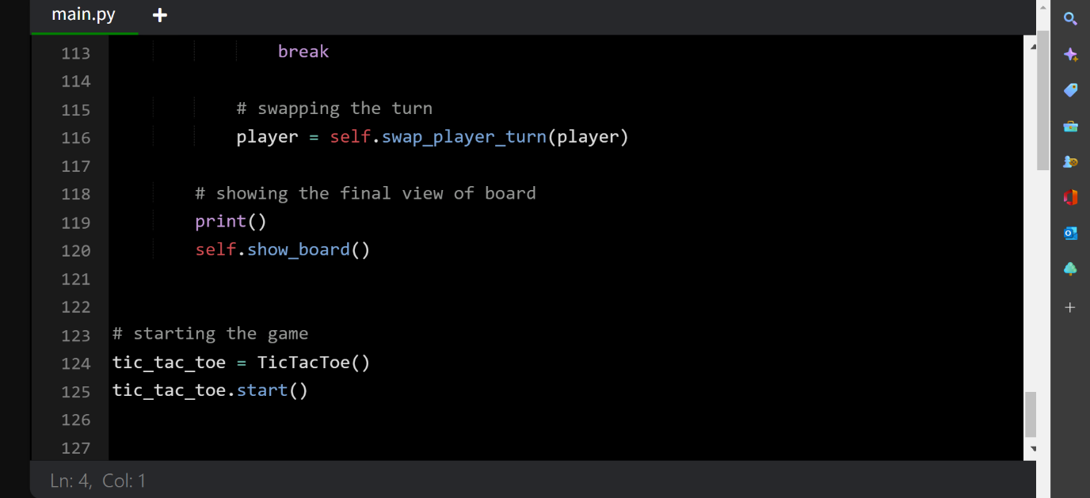

**RESULTS:**

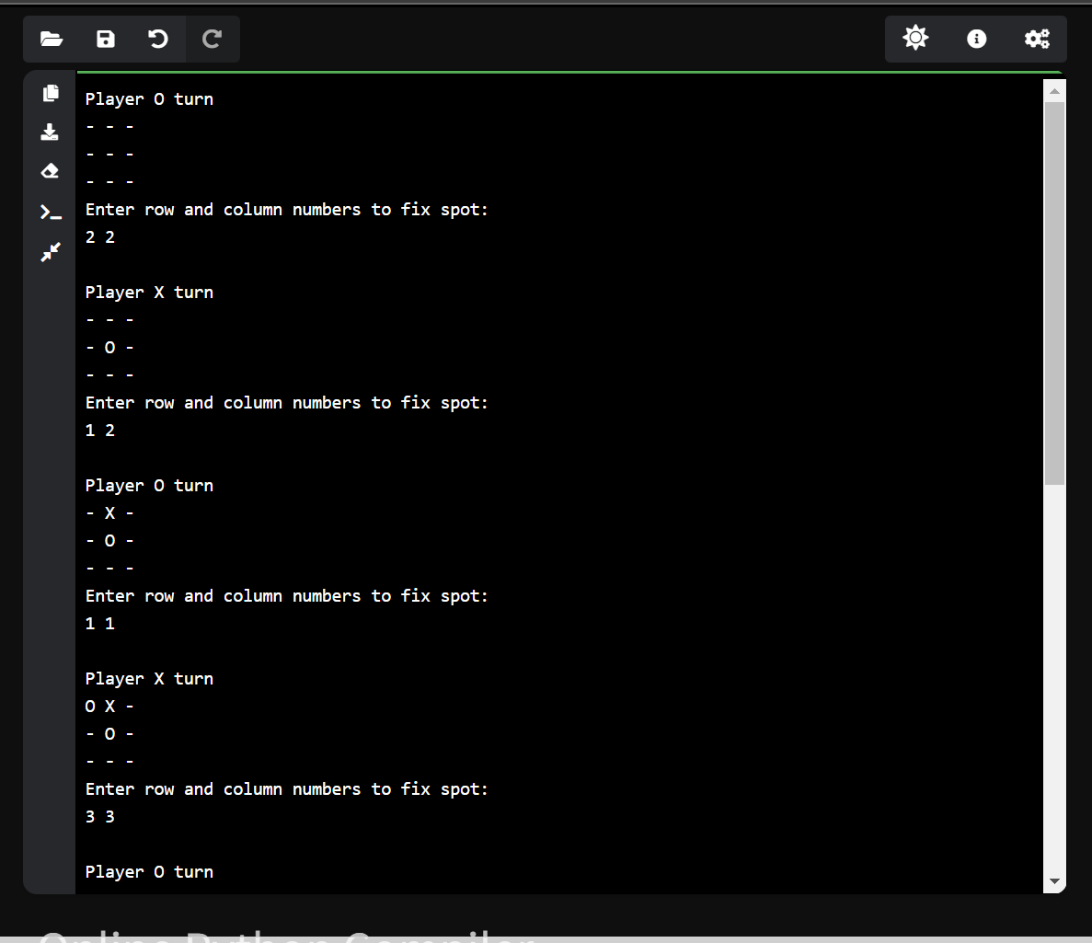

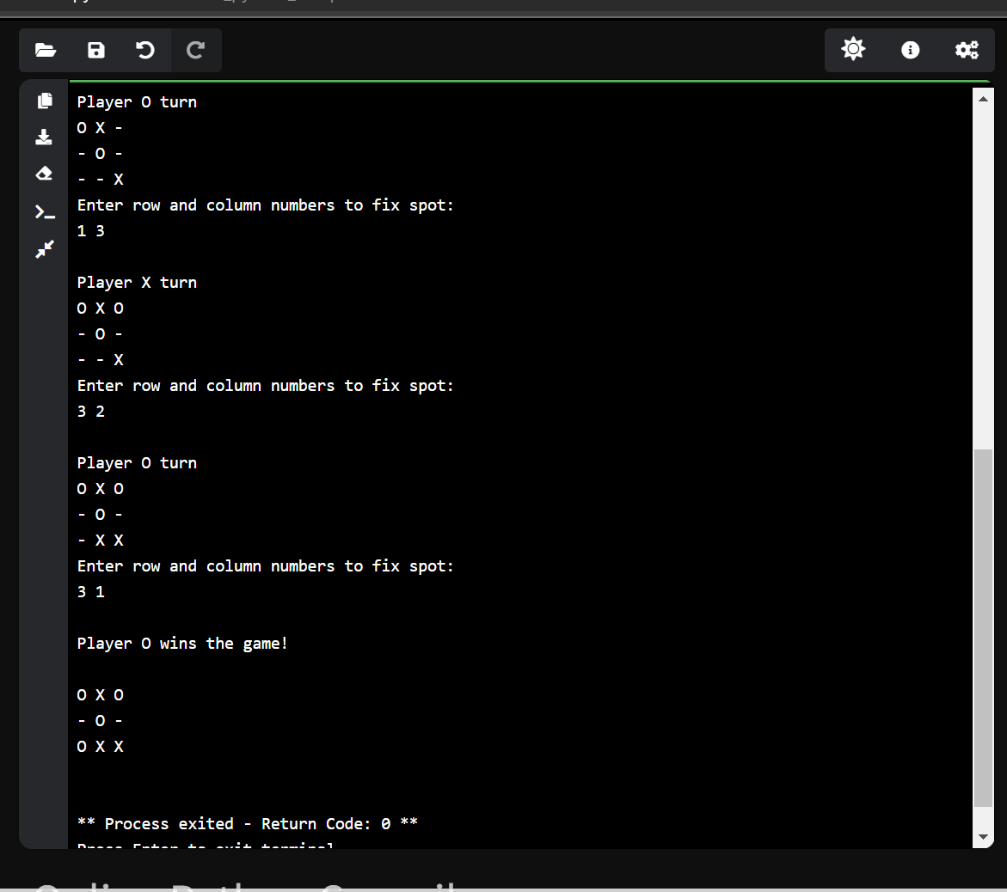

**CONCLUSION:**

**The Python Tic Tac Toe game is created using the basic features of Python. We have used basic if-else conditions along with function calls based on user input. In future, we can also add the names for the player. we can also keep track of the number of times the players play and the number of wins using a scoreboard. We can also change the markers from the typical ‘X’ and ‘O’ to the desired characters. We can also have a time limit for each turn. The board can be filled with a desired color. It can be enhanced by using animation and have different levels according to the difficulty.**